Report: EVI monitoring of forest operations timings

# **Introduction**

The report illustrates processes of detection of forest operations (thinning) timings of targeted forest stands, with the aim of filling missing the information of when forest operations occurred that would be required for further study in these stands. The reason for this process was because the operation dates of studied forest stands were not recorded during the field study. Hence, a time series analysis of the Enhanced Vegetation Index (EVI) to detect anomalies in those stands’ vegetation levels, which, with careful analyzation, can help to extract the timing of forest operations.

There are 40 stands in the study, located in Finland (mostly in the south and central part of Finland). From information collected from the inventory, most of the operations occurred in these stands are (first and second) thinning operations, with 27 sites went under first thinnings, 11 sites were second thinnings and the two remaining ones were shelterwood cutting. The primary goal is to refine the timing of forest thinning operations within targeted stands, with a preference for pinpointing specific dates. However, the detection of operation months is deemed equally valuable in providing substantial data for further analysis.

# Methods

The first step was to collect data of vegetation index values of forest stands for temporal analysis. The vegetation index (VI), formulated through the mathematical combination of two or more spectral bands associated with the characteristics of vegetation is a powerful tool for phenologic monitoring (Matsushita et al. 2007). Two types of indexes were considered: the Normalized Difference Vegetation Index (NDVI) and the Enhanced Vegetation Index (EVI). EVI is a more complex index compared to NDVI. It is calculated using the red, blue, and near-infrared bands, and its formula includes a canopy background adjustment factor and an aerosol resistance term. The complexity of the formula enhances its sensitivity and reduces the impact of atmospheric conditions on the vegetation signal (Matsushita et al. 2007), making it particularly valuable in areas prone to atmospheric interference, such as Finland. In addition, with Finland has an extensive forest cover, EVI's ability to reduce saturation in areas with high biomass, such as dense forests, ensures that the index remains informative. Hence, EVI was chosen as the monitored index in this analysis.

EVI values were collected for each of the 40 forest stands, calculated using the red, blue, and near-infrared bands (NIR):

*EVI = 2.5* ((NIR - RED) / (1 + NIR + 6 * RED - 7.5 * BLUE)*

To obtain those bands values, Sentinel-2 (European Space Agency satellite mission that provides high-resolution optical imagery) satellite imagery was used, where red band is B4 band, blue band is B2 and NIR band is B8. The value extraction process was facilitated using Google Earth Engine (See Appendix 1). We calculated the EVI values within the selected stands from 2015 to 2022.

The EVI values were extracted to monitor the changes in forest density using abrupt changes of EVI values over the time. We calculated Z-score values to determine the deviation of EVI values from the long-term mean in a specific cell for a specific time:

*Z = (EVI – MeanEVI)/SdEVI*

where:

* EVI is the individual Enhanced Vegetation Index value for a specific observation of a specific date
* MeanEVI is the mean (average) of the EVI values in the targeted month (where the observation occurred)
* SdEVI is the standard deviation of the EVI values in the targeted month (where the observation occurred)

The calculation and visualization of Z-score was done using R Studio (see Appendix 2).

# Results

After calculating and visualizing Z-score trends, downward trends of those values can be determined. Possible forest operation timings would be around the point when the Z score value started the downward trend. Results of the analysis are shown in Table 1.

*Table 1. Results of forest operations timing detection*

|  |  |  |
| --- | --- | --- |
| **Stands** | **Forest operation Month** | **Possible date** |
| Stand 14 | May | 01/05/2019 |
| Stand 15 | Apr | 11/04/2019 |
| Stand 22 | Jun | 28/06/2019 |
| Stand 26 | Jun | 12/06/2019 |
| Stand 29 | Dec | 21/12/2019 |
| Stand 40 | Apr | 11/04/2019 |
| Stand 42 | Feb | 06/02/2020 |
| Stand 44 | Feb | 27/02/2020 |
| Stand 46 | Mar | 11/03/2019 |
| Stand 47 | Apr | 11/04/2019 |
| Stand 48 | Feb | 04/02/2020 |
| Stand 51 | Feb | 04/02/2020 |
| Stand 52 | Aug | 08/08/2018 |
| Stand 55 | May | 04/05/2020 |
| Stand 56 | May | 04/05/2020 |
| Stand 58 | Apr | 05/04/2020 |
| Stand 61 | Apr | 23/04/2018 |
| Stand 62 | Apr | 15/04/2019 |
| Stand 71 | Apr | 05/04/2020 |
| Stand 73 | Jun | 23/06/2019 |
| Stand 75 | May | 01/05/2019 |
| Stand 76 | Jul | 25/07/2019 |
| Stand 78 | Mar | 01/03/2020 |
| Stand 79 | Jan | 21/01/2019 |
| Stand 81 | Jan | 21/01/2020 |
| Stand 83 | Apr | 01/04/2019 |
| Stand 85 | Apr | 11/04/2019 |
| Stand 86 | Feb | 06/02/2020 |
| Stand 87 | Mar | 09/03/2019 |
| Stand 92 | Jun | 02/06/2019 |
| Stand 93 | Apr | 23/04/2019 |
| Stand 96 | Apr | 11/04/2019 |
| Stand 97 | May | 18/05/2019 |
| Stand 101 | Apr | 11/04/2019 |
| Stand 105 | Feb | 04/02/2020 |
| Stand 119 | Apr | 19/04/2019 |
| Stand 128 | Apr | 05/04/2020 |
| Stand 130 | Mar | 19/03/2020 |
| Stand 139 | Apr | 23/04/2019 |
| Stand 140 | Mar | 08/03/2020 |

Possible specific date of forest operations could have inaccuracy range from 1 to 2 weeks as it is difficult to pinpoint the exact dates of operations. Nevertheless, the information of the month that operations could occur is still valuable insight for the research.

To validate the analysis results, real-color satellite images were also retrieved for visualization check. If the images of the forest stand show decreases in greenness around the observation date, it would mean that forest operations possibly occurred around the timing. Images were acquired from sentinel 2 database from Copernicus database. However, in a lot of cases, there are lack of images in the past dates. Hence, the process of downloading and visualizing forest stands images was also done via Google Earth Engine as a second method (See Appendix 3), which might lead to variety of images quality shown in the report. Most of the cases showed promising results that were in line with the analysis. However, in some cases the quality of images was not sufficient to produce any confirmation. Several examples of this process are shown in figures below.

Figure 1. Stand 55 - Late April 2020

Figure 2. Stand 55 - May 2020 (best quality picture at 23-05-2020)

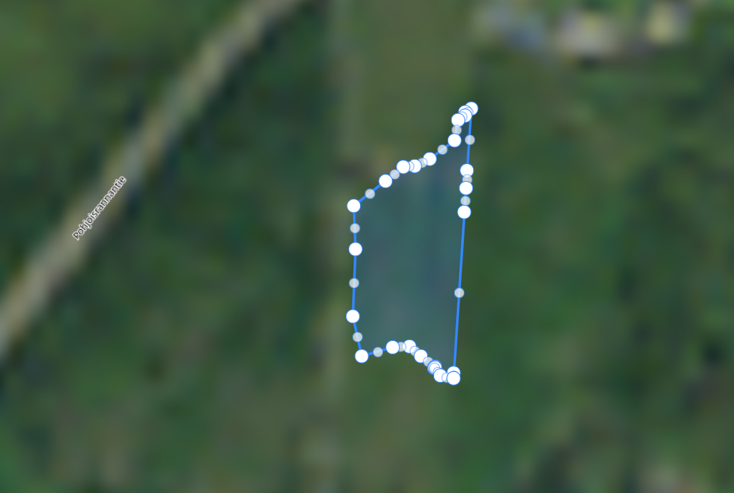

Figure 3. Stand 56 - Late April 2010

Figure 4. Stand 56 (19/05/2020)

Figure 5. Stand 92 (Late May 2019)

Figure 6. Stand 92 (04/06/2019)

*Figure 7. Stand 93 (grey border) from 23/04/2019 (left) into month May (right picture)*

# Discussion

From the summary of the results (Figure 7), April is the most common operations month (37%), followed by early summer months (May and June). Considering the major type of operation in these forest stands is thinning, conducting thinning in the spring/early fall aligns with the beginning of the growing season. This timing allows the remaining trees to benefit from increased sunlight, nutrients, and reduced competition, potentially enhancing their growth, provides an early opportunity for the remaining trees to recover from the disturbance. However, rains and snow melts, and active pests season make these period of months less ideal for operations in general (Grzywiński et al. 2019).

*Figure 7. Count of Forest operation Months*

The lack of information about the timings of forest operations from contractors led to this study research about forest operations timing detection. The usage of remote sensing with EVI monitoring and Sentinel 2 imagery has shown promise, albeit not without its share of shortcomings and challenges. Instead of knowing the exact time and date, operation timings are all estimations at best, leaving the chance for inaccurate data. EVI value monitoring was inconsistent for December and January, likely because of cloud and snow condition in Finland, which also affected images quality of several cases, making it difficult for the visual re-check. It partly explains why there is a lack of winter months in the results. In summation, this methodology may be deemed adequate for subsequent analyses, particularly when exclusively considering the months of operations. It is imperative, however, to maintain cognizance that the outcomes represent estimations derived from observations, thereby inherently harboring the potential for data inaccuracies.

5. Publication bibliography

Grzywiński, Witold; Turowski, Rafał; Naskrent, Bartłomiej; Jelonek, Tomasz; Tomczak, Arkadiusz (2019): The Effect of Season of the Year on the Frequency and Degree of Damage during Commercial Thinning in Black Alder Stands in Poland. In *Forests* 10 (8), p. 668. DOI: 10.3390/f10080668.

Matsushita, Bunkei; Yang, Wei; Chen, Jin; Onda, Yuyichi; Qiu, Guoyu (2007): Sensitivity of the Enhanced Vegetation Index (EVI) and Normalized Difference Vegetation Index (NDVI) to Topographic Effects: A Case Study in High-density Cypress Forest. In *Sensors (Basel, Switzerland)* 7 (11), pp. 2636–2651. DOI: 10.3390/s7112636.

# 6. Appendices

Appendix 1

**EVI value extraction with GEE**

**// Design the study area (our forest stands)**

Map.addLayer(Stand76);

var studyArea = ee.FeatureCollection(Stand76).geometry();

Map.addLayer(studyArea, {color:'green'}, 'Border');

Map.centerObject(studyArea);

**//** **Cloud Masking**

function maskS2clouds(images) {

var qa = images.select('QA60');

var cloudBitMask = 1 << 10;

var cirrusBitMask = 1 << 11;

var mask = qa.bitwiseAnd(cloudBitMask).eq(0).and(qa.bitwiseAnd(cirrusBitMask).eq(0));

return images.updateMask(mask).divide(10000).copyProperties(images).set('system:time_start', images.get('system:time_start'));

}

**//** **Filter images from Sentinel 2**

var images_filtered = ee.ImageCollection('COPERNICUS/S2_HARMONIZED')

.filter(ee.Filter.lt('CLOUDY_PIXEL_PERCENTAGE', 10))

.filterDate('2015-01-01', '2022-12-31')

.filter(ee.Filter.lte('CLOUDY_PIXEL_PERCENTAGE', 10))

.filterBounds(studyArea)

.map(maskS2clouds);

print(images_filtered);

**// EVI calculation**

var addEVI = function(image) {

var evi = image.expression(

'2.5 * ((NIR - RED) / (1 + NIR + 6 * RED - 7.5 * BLUE))',

{

'NIR': image.select('B8'),

'RED': image.select('B4'),

'BLUE': image.select('B2')

}

);

return evi.copyProperties(image, ['system:index', 'system:time_start']);

};

var addEVI = images_filtered.map(addEVI);

print(addEVI);

var img_filtered_clip = images_filtered.first().clip(studyArea);

var nd = addEVI.first().clip(studyArea);

**// Visualization**

var chart = ui.Chart.image.seriesByRegion({

imageCollection: addEVI,

regions: studyArea,

reducer: ee.Reducer.mean(),

scale: 10,

seriesProperty: 'class'

});

print(chart);

Appendix 2

**Z-score calculation with R**

**# Import data**

rm(list = ls())

evi <- read.csv2(file.choose(), header = TRUE)

library(dplyr)

evi <- distinct(evi)

head(evi)

evi$Date <- as.Date(paste(evi$Year, evi$Month, evi$Date, sep = "-"), format = "%Y-%b-%d")

library(openxlsx)

library(ggplot2)

**# Create a function to calculate Z score sorted by MONTHS**

calculate_monthly_z_scores <- function(data, month) {

month_data <- data %>%

filter(Month == month)

# Calculate the mean and standard deviation for the specified month

mean_month <- mean(month_data$EVI, na.rm = TRUE)

std_month <- sd(month_data$EVI, na.rm = TRUE)

# Calculate Z-scores for the specified month

month_data <- month_data %>%

mutate(Z_Score = (EVI - mean_month) / std_month)

return(month_data)

}

**# Apply the function**

Jan <- calculate_monthly_z_scores(evi, "Jan")

Feb <- calculate_monthly_z_scores(evi, "Feb")

Mar <- calculate_monthly_z_scores(evi, "Mar")

Apr <- calculate_monthly_z_scores(evi, "Apr")

May <- calculate_monthly_z_scores(evi, "May")

Jun <- calculate_monthly_z_scores(evi, "Jun")

Jul <- calculate_monthly_z_scores(evi, "Jul")

Aug <- calculate_monthly_z_scores(evi, "Aug")

Sep <- calculate_monthly_z_scores(evi, "Sep")

Oct <- calculate_monthly_z_scores(evi, "Oct")

Nov <- calculate_monthly_z_scores(evi, "Nov")

Dec <- calculate_monthly_z_scores(evi, "Dec")

**# Combine all the monthly Z-score data frames into one**

all_monthly_data <- bind_rows(

Jan, Feb, Mar, Apr, May, Jun,

Jul, Aug, Sep, Oct, Nov, Dec

)

**# Plotting**

ggplot(all_monthly_data, aes(x = Date, y = Z_Score)) +

geom_line() +

labs(x = NULL, y = "Z Score") +

ggtitle("Z Scores Over Time (2015-2022)") +

scale_x_date(date_labels = "%Y", date_breaks = "1 year") +

facet_wrap(~Month, scales = "free_x")

**# Export to Excel**

write.xlsx(all_monthly_data, "evi14_Zscore_Months.xlsx", rowNames = FALSE)

Appendix 3

**Real-color images collection with GEE**

**// Load Sentinel-2 data**

var sent2 = ee.ImageCollection('COPERNICUS/S2_SR');

var image = ee.Image(sent2

.filterDate("2020-02-26", "2020-03-08")

.filterBounds(studyArea)

.sort("CLOUD_COVERAGE_ASSESSMENT")

.first());

Map.addLayer(image, {min:450, max:4500, bands:['B4','B3','B2']}, 'Sentinel 2 RGB L2A', false);

var trueColor = {

bands: ["B4", "B3", "B2"],

min: 0,

max: 3000

};

Map.addLayer(image, trueColor, "True Color Image");

**// Selecting the SCL (Scene Classification Band)**

var scl = image.select('SCL');

Map.addLayer(scl, {min:1, max:11}, 'SCL Band', false);

**// Selecting the cloud shadow and cloud masks (3,7,8,9);**

var cloud_shadow = scl.eq(3);

var cloud_low = scl.eq(7);

var cloud_medium = scl.eq(8);

var cloud_high = scl.eq(9);

Map.addLayer(cloud_high, {min:0,max:1, palette:['black','red']}, 'Cloud High Binary Mask', false);

**// Merging the masks together**

var cloud_mask = cloud_shadow.add(cloud_low).add(cloud_medium).add(cloud_high);

Map.addLayer(cloud_mask, {min:0, max:1, palette:['black','red']}, 'Merged Cloud Masks', false);

**// Creating a uniary mask image from the binary mask image i.e. replacing the black with nulls**

var cloud_uni = cloud_mask.eq(0).selfMask();

Map.addLayer(cloud_uni, {palette:['red']}, 'Cloud Uniary Mask', false);

**// Finally masking the original image (or bands) with cloud mask**

var cloud_masked = image.updateMask(cloud_uni);

Map.addLayer(cloud_masked, {min:1251, max:6001, gamma:1.6, bands:['B4','B3','B2']}, 'Cloud Masked');

**// TRANSPARENT Study Border**

var shown = true; // true or false, 1 or 0

var opacity = 0.05; // number [0-1]

var nameLayer = 'border'; // string

var visParams = {color: '#FFFFFF77'};

Map.addLayer(studyArea, visParams, nameLayer, shown, opacity);

**// Zoom to study area**

Map.centerObject(studyArea, 15);